Student Name:
Unit:
Prof:
Date:
A Comprehensive Final Art Essay
Essay 1: Diverse Representation of the Human Figure
The making of artworks is usually situational as an artistic desired to produce works that speak about the place, context, or particular movement at the time. This essay explores the work of two artists, Francis Bacon from the surreal period and Barkley L. Hendricks on Black feminine awareness. Their artworks were unique, each reflecting a unique message they passed in fairly different times.
Firstly, there is Francis Bacon, an Irish-born artist who embraced the biomorphism technique present human figures in amorphous and distorted ways. The series of human portraits shown below are artworks of Francis Bacon, who belonged to the art movement of surrealism. In this movement, artists broke the ceiling and embraced artworks that altered the limits of human consciousness by offering unique visual presentations involving uncensored imagery (Arbor 26). Surrealists were rebels in art and perceived the human mind as free from rationalism and political correctness that existed back in that time.

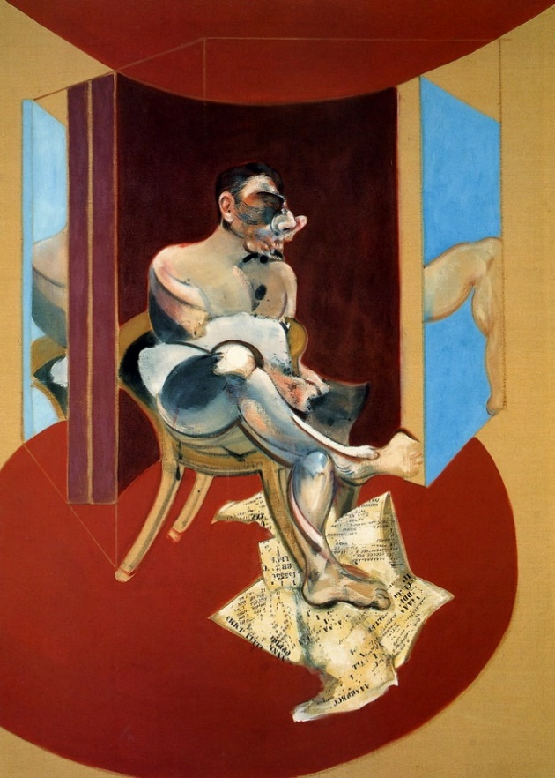  Figure 1: Study of George Dyer (1969) | 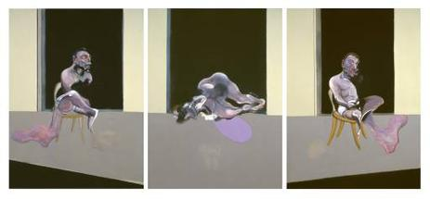  Figure 2: Triptych August 1972
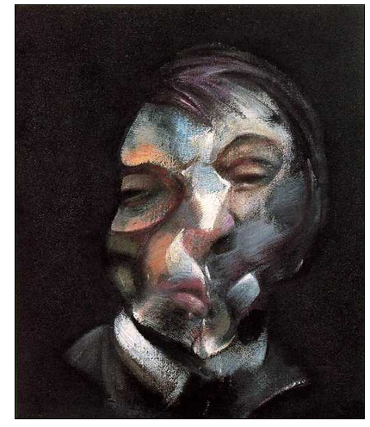
Figure 3: Self-Portrait (1971)

As a surrealist, Bacon, in particular, used biomorphism, a technique to alter the form of a human, to depict the horror, suffering, and mystery that humans endured. His works, such as the study of George Dyer (1969), entailed deformed figures to highlight the physical suffering in the post-World War II period. In other paintings such as Self-Portrait (1971), Bacon created torqued faces devoid of artistic appeal to underpin emotions of emptiness, solace, and psychological suffering (Jarvis 183). Through this crudeness and lack of form, Bacon was an impressive visual storyteller in capturing the brokenness and suffering of the day.

Figure 4: Lawdy Mama (1969)
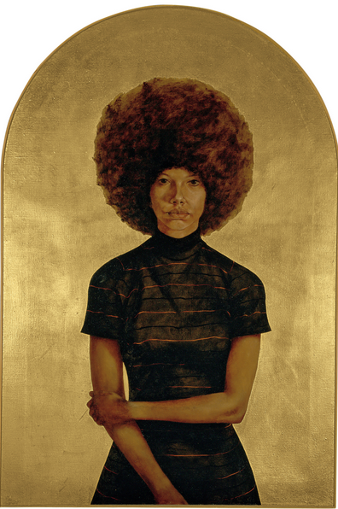
On the other hand, there is the African-American artist Barkley L. Hendricks with her iconic painting ‘Lawdy Mama,’ an epitome of Black feminine pride and consciousness. Sitting in the Smith College Museum of Art, Hendrick’s painting (shown in Fig. 4 below) is considered contemporary art that speaks about the ordinariness of any black woman. The 1960s was a remarkable period, the Civil war era, which about the consciousness of blackness in America. Hendricks made the painting to celebrate and humanize the black female subject and raise the consciousness of the importance of the African American woman not just in the domestic space but nationally. The painting illuminates pride, passion and projected a dignified appeal of the woman of color (Bacon). Therefore, for each of the artists, the representation of the human portrait was unique and underscored the intended message when creating the art.

Essay 2: Evolving purposes and forms of art in the Modern Era
Art has evolved over the centuries, and today, self-expression in art is more diverse, wild, and global. With time, new techniques have been mastered in painting and other forms of art, such as photography and sculpture. In the olden times, artists were more limited in terms of themes and geographical location. For instance, many classical paintings in Europe and America were on issues affecting human life in those domains. However, in the new era, facilitated by information explosion and digitization, youthful artists tell global stores often from a local point of view. Storytelling in art has become more intense and reflects the diversity in methods used and thoughts. Bu using different techniques and approaches, artist’s personal self-expression today has become bolder and more daring. Today artists can use street murals, canvas, cloth, cars, their bodies, and virtually everything to express themselves.
Figure 5: Street Mural by JR (1983)
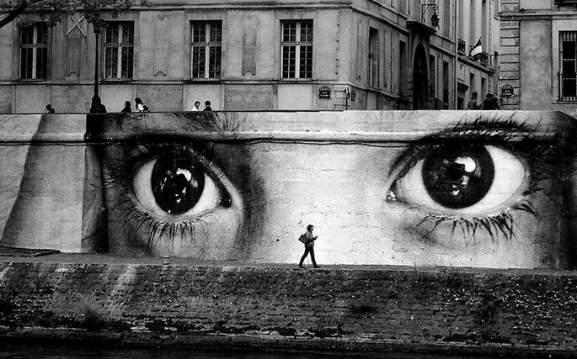
Additionally, for many artists, art has presented greater voice over specific issues in society to a grander scale than ever before. For instance, JR is a contemporary American artist that has created countless street morals expressing different themes. He considers himself an art activist exploring different societal issues. For instance, the mural in Figure 5 above shows a terrified child with teary eyes. It captures the issue of child abuse, neglect and improper care. It highlights the importance of protecting the children from harm and abuse and truly sensitizes the general public due to its clarity and vastness.
Figure 6: Plastics in the Oceans (Vasco Gargalo, 2018)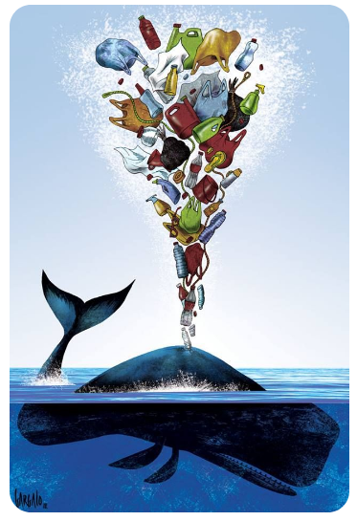
Finally, in the modern era, artists have taken a greater interest in global issues and made their stand on the progress of society. Modern artists have been bolder in issues of stopping human trafficking, child abuse, family-based violence, drug usage, and climate change, among others. With their individual contributions, they increase the clarity of the message and help sway the public’s viewpoints on these core issues. For instance, in figure 6 above, Vasco Gargalo joins a battalion of pro-environment art activism in saving marine life. The painting involves a whale spouting out an assortment of human junk that is usually dumped in the ocean. Such artists like Gargalo help drive national, regional, or global debate and add insights into specific contexts on which their artworks base on. Ultimately, it is right to argue that contemporary artists are more visionary, bold, and far more innovative than their predecessors. Besides, today, there are more avenues to create and showcase art and public visibility is essential in sensitization or criticism.

Works Cited
Arbor, Ann. Manifestoes of Surrealism in Nutrition and the Mentally Retarded. Michigan: University of Michigan Press, 1972. Print
Bacon, Camille. Lawdy Mama (1969): Celebrating the Ordinariness of Black Women in ‘Black Refractions'. SCMA. April 23, 2020. Web. 20 March 2021, < https://scma.smith.edu/blog/lawdy-mama-1969-celebrating-ordinariness-black-women-black-refractions >
Jarvis, Michael. Francis Bacon and the practice of painting. Journal of Visual Arts Practice, 8 (3), (2009), 181-194 Doi: 10.1386/jvap.8.3.181/1

